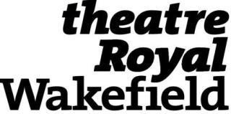

Theatre Hire and Equipment Rate Card 2025/2026
Item | Hourly | Daily | Weekly
Matcham Auditorium Hire
7 Days (Sun-Sat) |  |  | £8890
4 Days (Wed-Sat) |  |  | £6160
Sunday |  | £2080
Monday |  | £1385
Tuesday |  | £1385
Wednesday |  | £1385
Thursday |  | £1680
Friday |  | £2080
Saturday |  | £2080
Technical Equipment
Radio mic | Price on request
Haze machine |  | £32 | £64
Lapel radio mic | Price on request
Mirror ball |  | £11 | £15
Music stand |  | £10 | £10
Projector | Price on request
Smoke machine |  | £32 | £64
Star cloth |  | £29 | £93
Technical Design
Lighting design |  | £520
Sound design |  | £520
Additional Staff
Technical Staff | £25 p/hr
Miscellaneous
Missed Break Charge | £185
Additional Access Charge | £185

*All charges are subject to VAT at the prevailing rate

